**DYNABREEZE INDUSTRIAL FANS:**

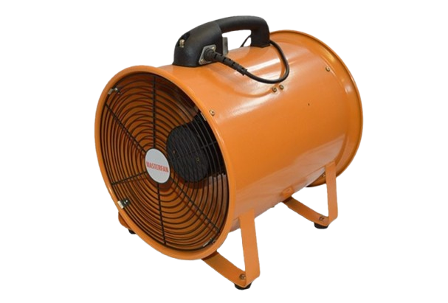

**Price: 15,000.00**

The Dynabreeze Industrial Fan is a heavy-duty ventilation solution, engineered to provide intense airflow and rugged reliability in demanding industrial environments. With its powerful motor and aerodynamic design, this fan delivers high-velocity air movement, effectively cooling large areas and improving air quality. Its durable construction, adjustable speed settings, and corrosion-resistant coating ensure long-lasting performance, making it an ideal choice for factories, warehouses, and other industrial settings.

**Key features of dynabreeze industrial fans include:**

* **High Airflow Output**: Designed to move large volumes of air for effective cooling.
* **Durable Construction**: Built with heavy-duty materials for long-lasting performance.
* **Adjustable Speeds**: Multiple speed settings for customizable airflow.
* **Energy Efficient**: Consumes less power while providing optimal performance.
* **Versatile Design**: Suitable for various industrial and commercial applications.
* **Portable**: Easy to move and reposition as needed.
* **Reliable Performance**: Designed for continuous use in demanding environments.